|  |
| --- |
| Software design |
| **House Ware Shopping Online System** |
| Version 1.0 |
| Prepared by class SE1314  **Group 1**  Nguyễn Khánh Huyền  Lê Hồng Quân  Lê Viết Tư  Apr 2, 2020 |

Contents

Revision history 4

Introducing MVC pattern 4

1. Document description 4

2. SRS overview 5

2.1. List of system users 5

2.2. List of use cases 5

2.3. Use case diagram 6

2.4. Activity diagrams of use case scenarios 6

2.4.1. Activity diagram for use case “Make Order” 6

3. Data model 8

3.1. Entity Relationship Diagram 8

3.2. Table details/Chi tiết các bảng 8

3.2.1. Table name: Account 9

3.2.2. Table name: Status_Acount 10

3.2.4 Table name: Role_Account 10

3.2.5 Table name: Product 10

3.2.6 Table name: Image 11

3.2.7 Table name: Status_Product 11

3.2.8 Table name: Category 11

3.2.9 Table name: Status_Category 11

3.2.10 Table name: Sub_category 12

3.2.11 Table name: Status_subCategory 12

3.2.12 Table name: Order 12

3.2.13 Table name: order_Detail 12

3.2.14 Table name: Status_order 13

3.2.15 Table name: Shipping 13

3.2.16 Table name: Views 13

4. Class diagram (p.61 – p70) 13

4.1. List of classes in the Layers 13

4.2. Modeling the Class Behaviors - sequence diagrams 14

4.2.1. Sequence diagram for use case “Make Order” 15

5. User Interface Model Design (p. 70 – p.74) 15

5.1. User interface model design 15

5.1.1. Screen “Authenticate” 16

5.1.2. Screen “Edit Profile” 17

5.1.3. Screen “Make Orders” 17

5.1.4. Screen “Manage Shop” 18

5.2. Interface Flow Diagrams (p. 51) 22

## Revision history

|  |  |  |  |
| --- | --- | --- | --- |
| **Date** | **Authors** | **Modifications** | **Version** |
|  |  |  |  |
|  |  |  |  |
|  |  |  |  |
|  |  |  |  |
|  |  |  |  |

## Introducing MVC pattern

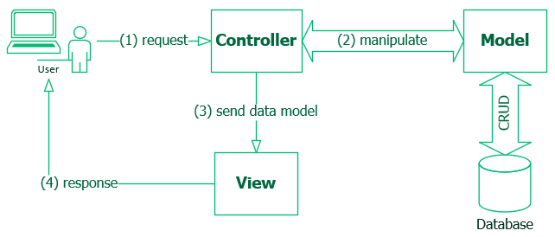

* **Model**: is a place to store user data, containing business logic. It allows data retrieval to display or collect data. The model is the bridge between the View component and the Controller. Its most important purpose is to connect the database (database), process data and prepare data to move to other components.
* **View**: is the interface of the system where data (Model) is displayed, receiving direct interaction with users. In a web application, View is part of the system, where the HTML code is generated and displayed. An important issue is that View is not able to get data directly from the Controller but through the Model.
* **Controller**: receives requests, data from the user, then updates to the Model and finally returns the View results to show the results to the user. The controller does not contain any business logic.

# Document description

This document describes OO solution version 1.0 for House Ware Shopping Online System. It is divided into the following sections:

* In the section 2 an overview of the Shopping system’s requirements will be provided, including list of system users, use cases, use case diagram, and activity diagrams that describes the most important use case scenarios.
* In the section 3 an E-R diagram and all tables of the Library system in detail will be presented.
* In the section 4 all classes organized in the layers and their behaviors (sequence diagrams) for the most important use cases will be presented.
* In the section 5 the most screen prototypes will be presented.

# SRS overview

## 2.1. List of system users

1. Admin:

o Administrators are the ones who adds or administers for the products, category, and account.

o The Administrator is the super user and has complete control over all the activities that can be performed.

* The application notifies the administrator of all shop creation requests, and the administrator can then approve or reject them.
* The administrator also manages the list of available product categories.
* The administrator can also view, edit, add and delete entries in the datatable.

2. Client:

o A Customer can browse through the shops and choose products to place in a virtual shopping cart. The shopping cart details can be viewed and items can be removed from the cart.

o To proceed with the purchase, the customer is prompted to login.

o Also, the customer can modify personal profile information (such as phone number and shipping address) stored by the application.

o The customer can also view the status of any previous orders, and cancel any order that has not been shipped yet.

## 2.2. List of use cases

1. Authenticate

2. Edit Profile

3. Make Order

4. View Chart

5. Manage Account

6. Manage Product

7. Manage Category

8. Manage SubCategory

9. Manage Order

## 2.3. Use case diagram

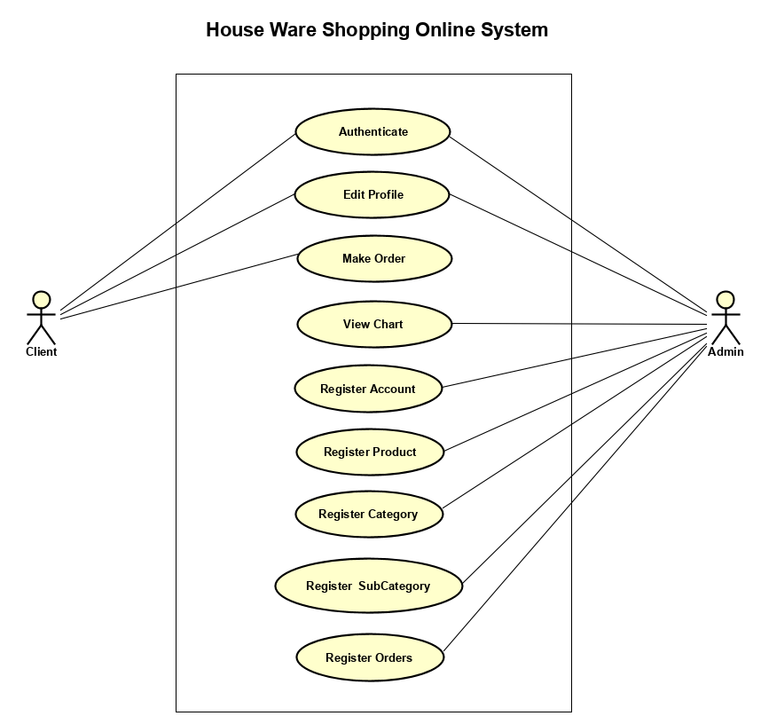

## 2.4. Activity diagrams of use case scenarios

### 2.4.1. Activity diagram for use case “Make Order”

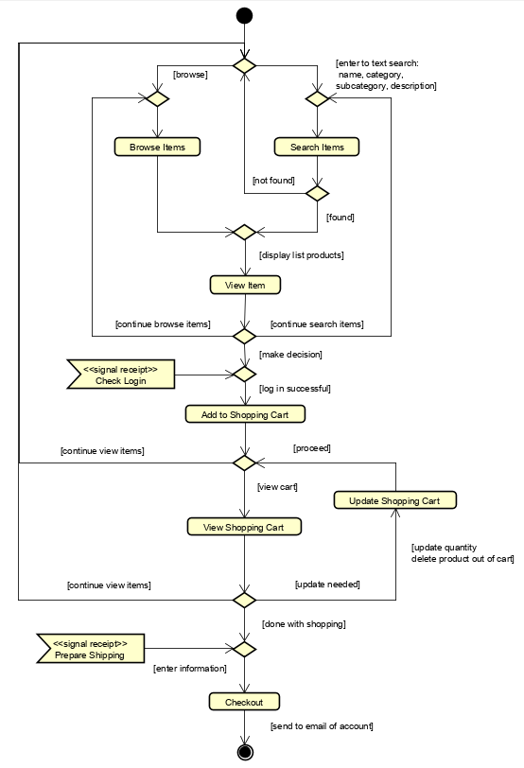

# Data model

## Entity Relationship Diagram

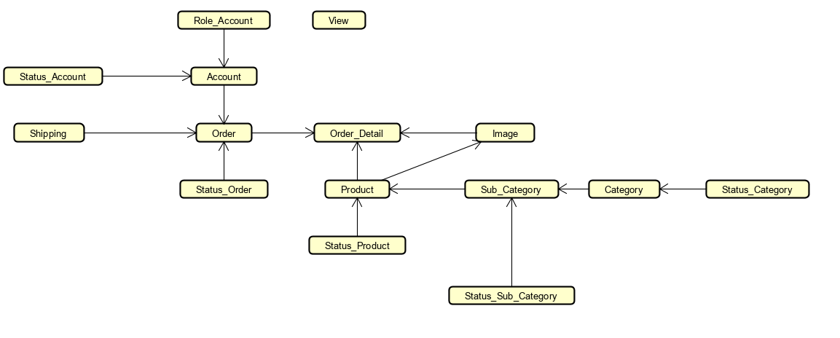

Note: one-to-many

## Table details/Chi tiết các bảng

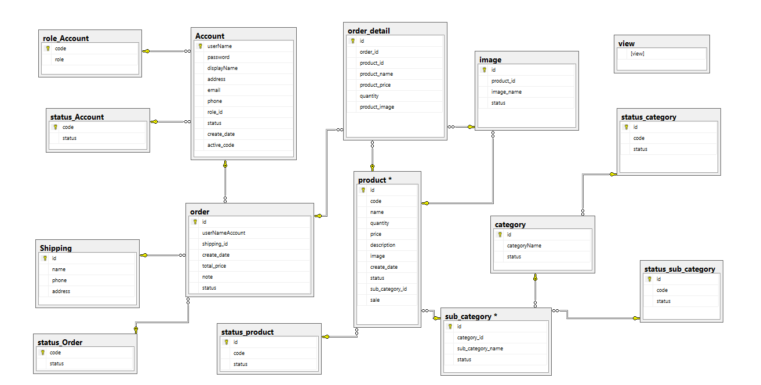

Note: Attribute with underline is Primary key

### Table name: Account

|  |  |  |  |
| --- | --- | --- | --- |
| **Field name** | **Type** | **Size** | **Note** |
| **userName** | String | 100 | Primary key |
| password | String | 50 | Not null |
| displayName | String | 100 | Allows null |
| Email | String | 100 | Allows null |
| Telephone | String | 50 | Allows null |
| Address | String | 200 | Allows null |
| role_id | Integer | 100 | Foreign key, refers to Role_Account table |
| status | Integer | 50 | Foreign key, refers to Status_Account table |
| create_date | Date |  | Not null |
| active_code | String | 50 | Allows null |
|  |  |  |  |

### Table name: Status_Acount

|  |  |  |  |
| --- | --- | --- | --- |
| **Field name** | **Type** | **Size** | **Note** |
| **ID** | Integer | 10 | Primary key |
| status | String | 50 | Not null |

### Table name: Role_Account

|  |  |  |  |
| --- | --- | --- | --- |
| **Field name** | **Type** | **Size** | **Note** |
| **role_id** | Integer | 10 | Primary key |
| role | String | 40 | Not null |

### Table name: Product

|  |  |  |  |
| --- | --- | --- | --- |
| **Field name** | **Type** | **Size** | **Note** |
| **ID** | Integer | 10 | Primary key |
| category_id | Integer | 10 | Foreign key, refers to Category table |
| code | String | 50 | Not null |
| name | String | 50 | Not null |
| quantity | Integer | 50 | Not null |
| description | String | 50 | Allows null |
| image | Image | 50 | Not null |
| create_date | date | 50 | Not null |
| status | Integer | 50 | Allows null |
| sub_category_id | Integer | 50 | Allows null |
| sale | Double | 50 | Allows null |

### Table name: Image

|  |  |  |  |
| --- | --- | --- | --- |
| **Field name** | **Type** | **Size** | **Note** |
| **ID** | Integer | 10 | Primary key |
| product_id | Integer | 10 | Foreign key, refers to Product table |
| Iamge_name | String | 100 | Not null |
| status | String | 50 | Allows null |

### Table name: Status_Product

|  |  |  |  |
| --- | --- | --- | --- |
| **Field name** | **Type** | **Size** | **Note** |
| **ID** | Integer | 10 | Primary key |
| code | String | 10 | Allows null |
| status | String | 50 | Allows null |

### 3.2.8 Table name: Category

|  |  |  |  |
| --- | --- | --- | --- |
| **Field name** | **Type** | **Size** | **Note** |
| **ID** | Integer | 10 | Primary key |
| categoryName | String | 10 | Foreign key, refers to Product table |
| status | Integer | 50 | Foreign key, refers to Status_Category table |

### Table name: Status_Category

|  |  |  |  |
| --- | --- | --- | --- |
| **Field name** | **Type** | **Size** | **Note** |
| **ID** | Integer | 10 | Primary key |
| code | String | 10 | Allows null |
| status | String | 50 | Allows null |

### Table name: Sub_category

|  |  |  |  |
| --- | --- | --- | --- |
| **Field name** | **Type** | **Size** | **Note** |
| **ID** | Integer | 10 | Primary key |
| categoryId | String | 10 | Foreign key, refers to Category table |
| status | Integer | 50 | Foreign key, refers to Status_Subcategory table |
| name | String | 50 | Not null |

### Table name: Status_subCategory

|  |  |  |  |
| --- | --- | --- | --- |
| **Field name** | **Type** | **Size** | **Note** |
| **ID** | Integer | 10 | Primary key |
| code | String | 10 | Allows null |
| status | String | 50 | Allows null |

### Table name: Order

|  |  |  |  |
| --- | --- | --- | --- |
| **Field name** | **Type** | **Size** | **Note** |
| **ID** | Integer | 50 | Primary key |
| Customer | String | 100 | Not null |
| shipping_id | Integer | 50 | Foreign key, refers to Shipping table |
| create_date | Date |  | Not null |
| total_price | Integer | 50 | Not null |
| status | Integer | 50 | Not null |
| note | String | 200 | Not null |

### 3.2.13 Table name: order_Detail

|  |  |  |  |
| --- | --- | --- | --- |
| **Field name** | **Type** | **Size** | **Note** |
| **ID** | Integer | 50 | Primary key |
| order_id | Integer | 100 | Foreign key, refers to order_id table |
| product_id | Integer | 50 | Foreign key, refers to Product table |
| product_name | Date |  | Not null |
| product_price | Integer | 50 | Not null |
| quantity | Integer | 50 | Foreign key, refers to status_order table |
| product_image | String | 200 | Not null |

### 3.2.14 Table name: Status_order

|  |  |  |  |
| --- | --- | --- | --- |
| **Field name** | **Type** | **Size** | **Note** |
| **Code** | Integer | 10 | Primary key |
| status | String | 50 | Allows null |

### 3.2.15 Table name: Shipping

|  |  |  |  |
| --- | --- | --- | --- |
| **Field name** | **Type** | **Size** | **Note** |
| **ID** | Integer | 10 | Primary key |
| Name | String | 50 | Allows null |
| Phone | String | 50 | Allows null |
| Address | String | 50 | Allows null |

### 3.2.16 Table name: Views

|  |  |  |  |
| --- | --- | --- | --- |
| **Field name** | **Type** | **Size** | **Note** |
| **viewNo** | Integer | 10 | Primary key |

# Class diagram (p.61 – p70)

## List of classes in the Layers

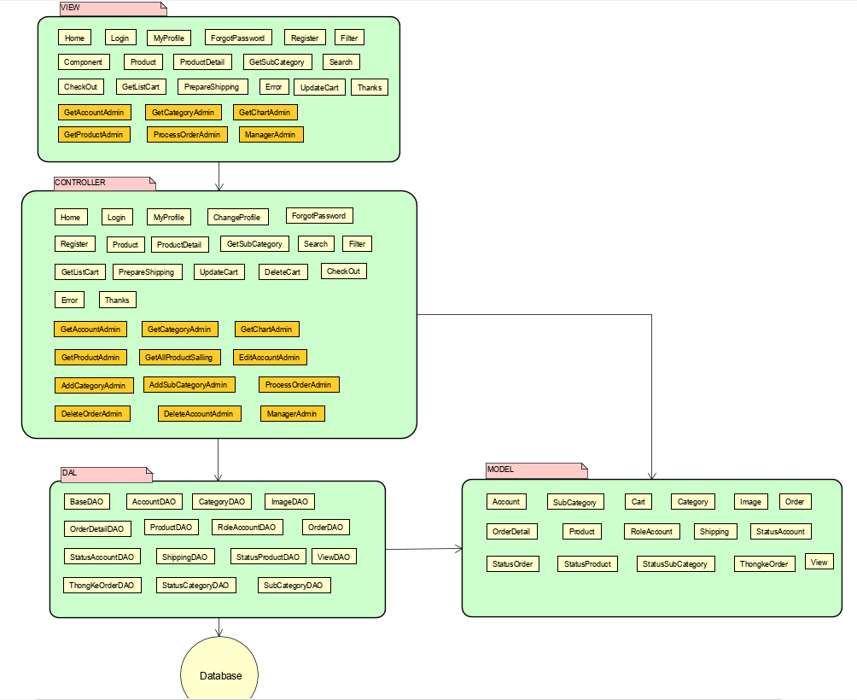

## Modeling the Class Behaviors - sequence diagrams

### Sequence diagram for use case “Make Order”

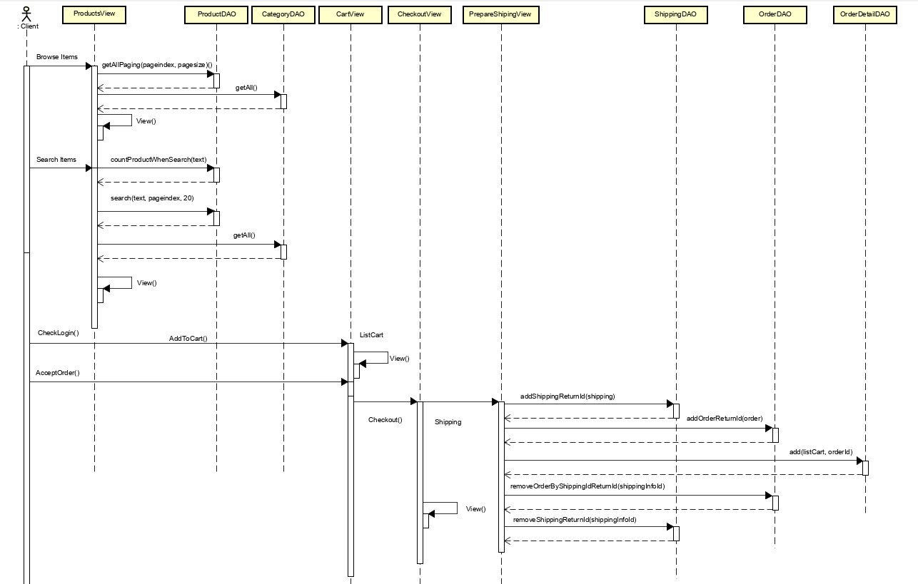

# User Interface Model Design (p. 70 – p.74)

## User interface model design

### 5.1.1. Screen “Authenticate”

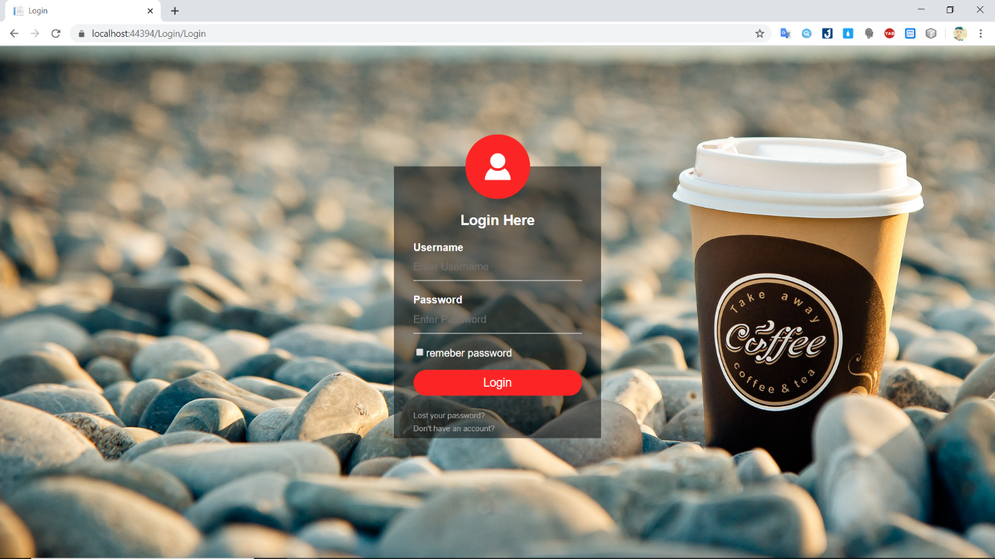

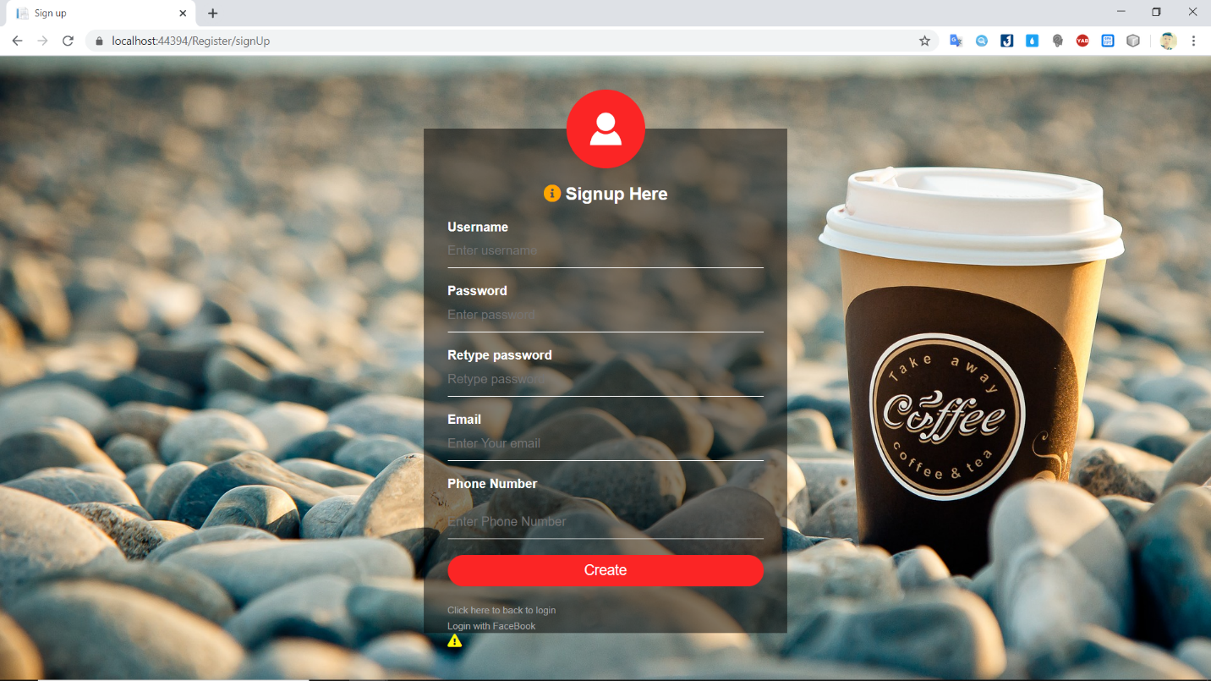

### 5.1.2. Screen “Edit Profile”

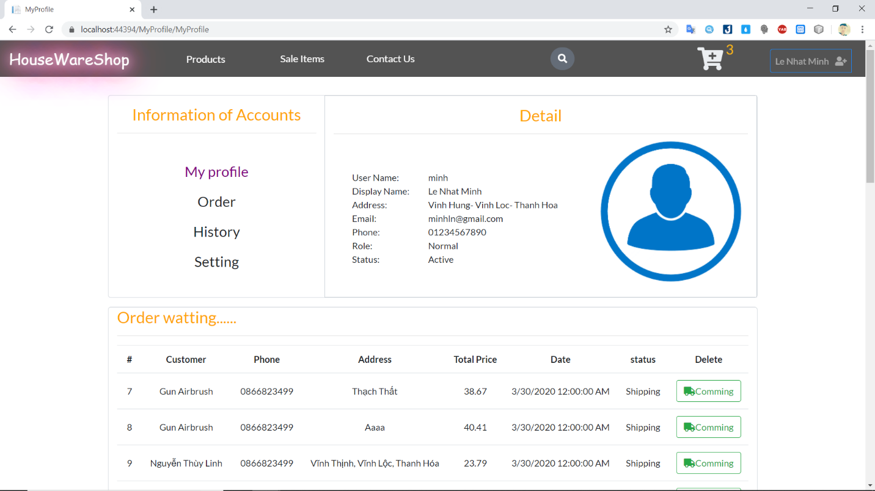

### 5.1.3. Screen “Make Orders”

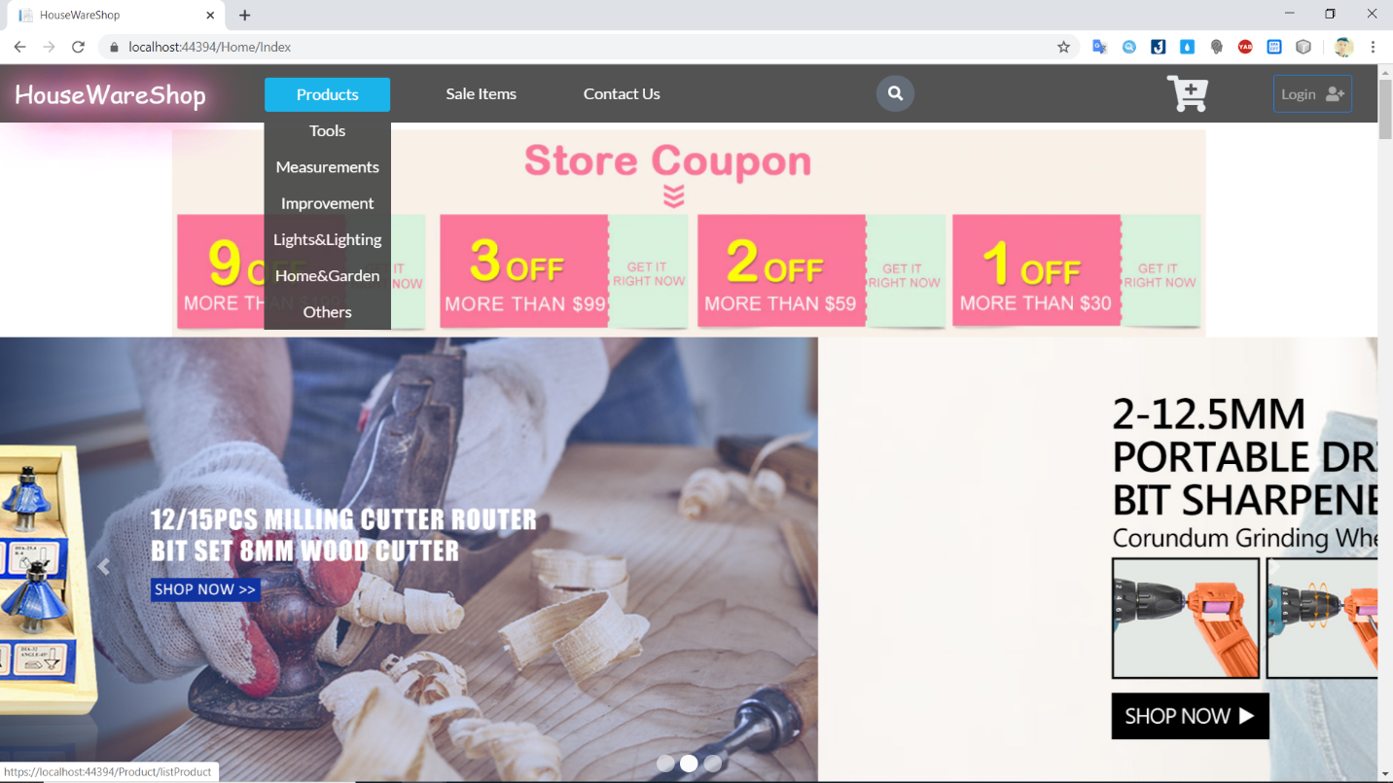

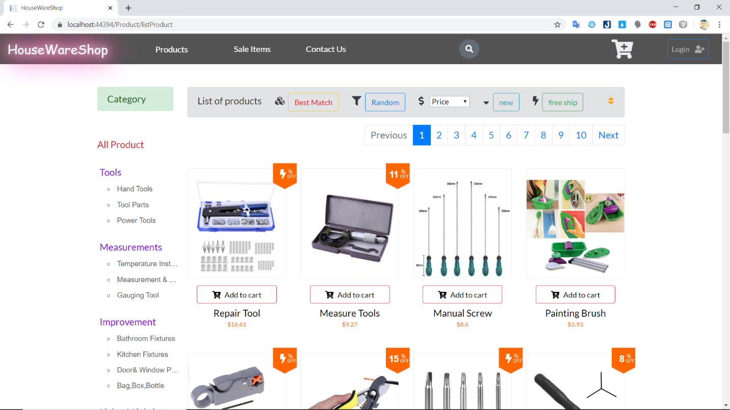

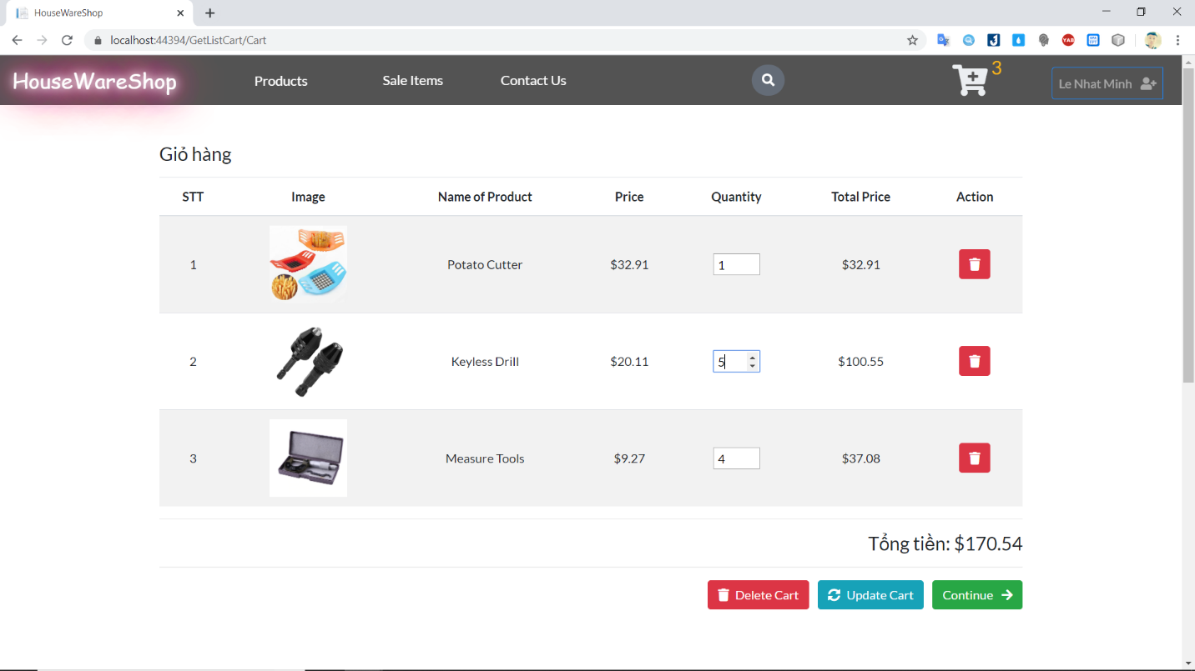

### 5.1.4. Screen “View Chart”

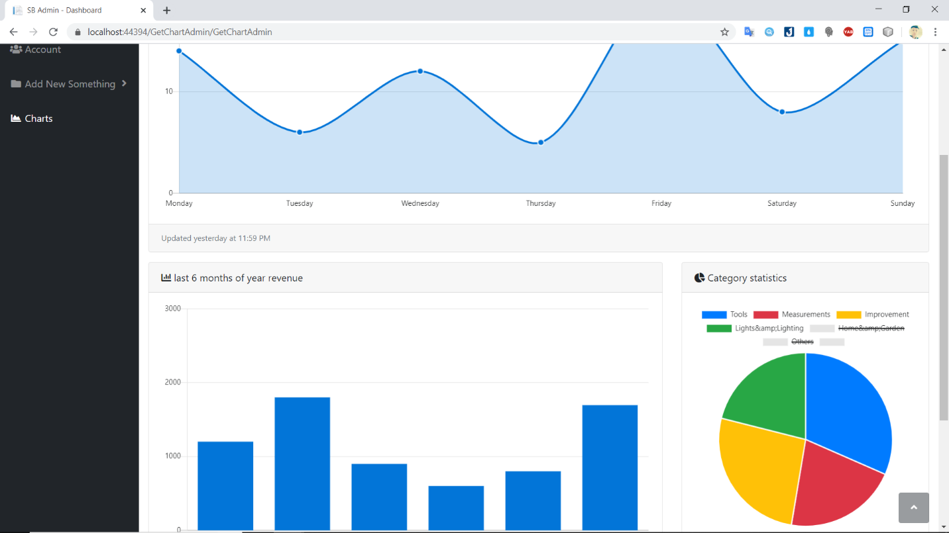

### 5.1.5. Screen “Manage Account”

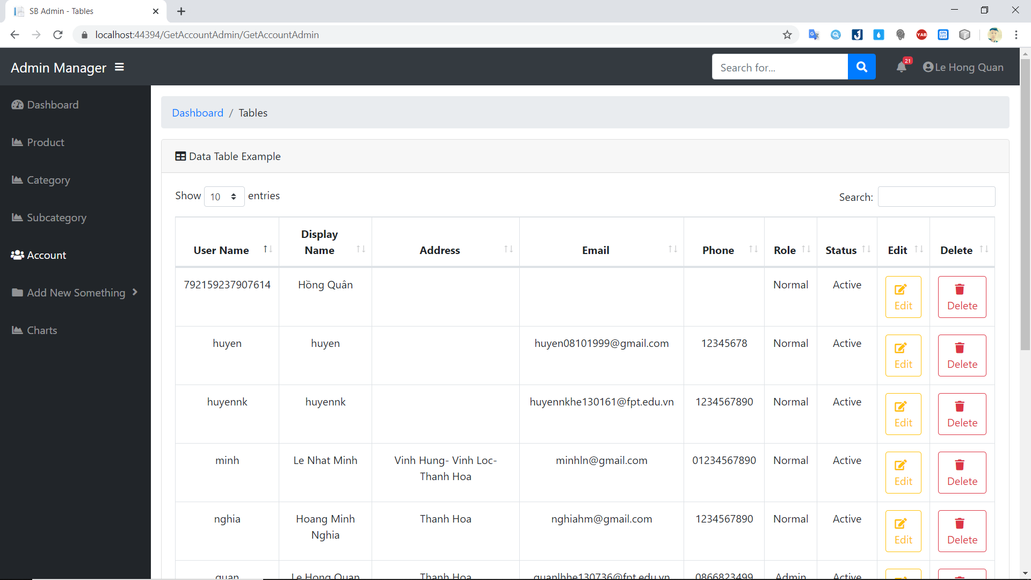

### 5.1.6. Screen “Manage Product”

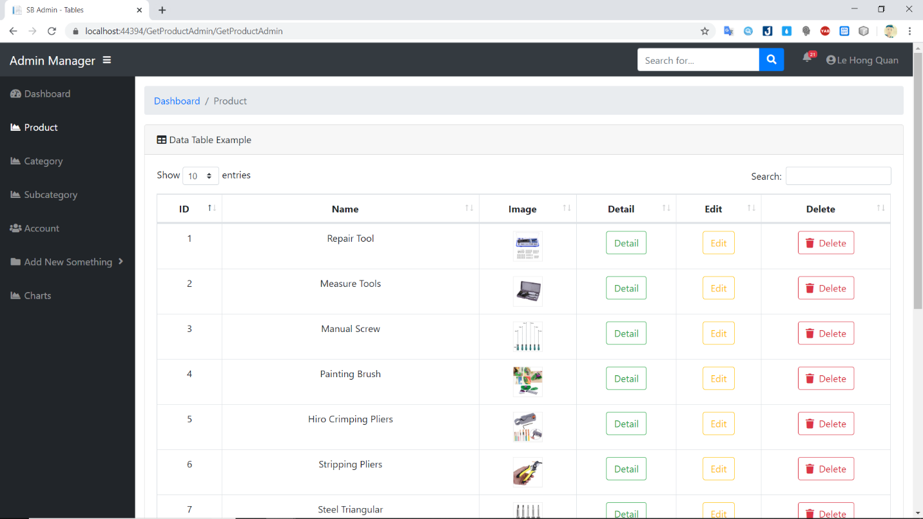

### 5.1.7. Screen “Manage Category”

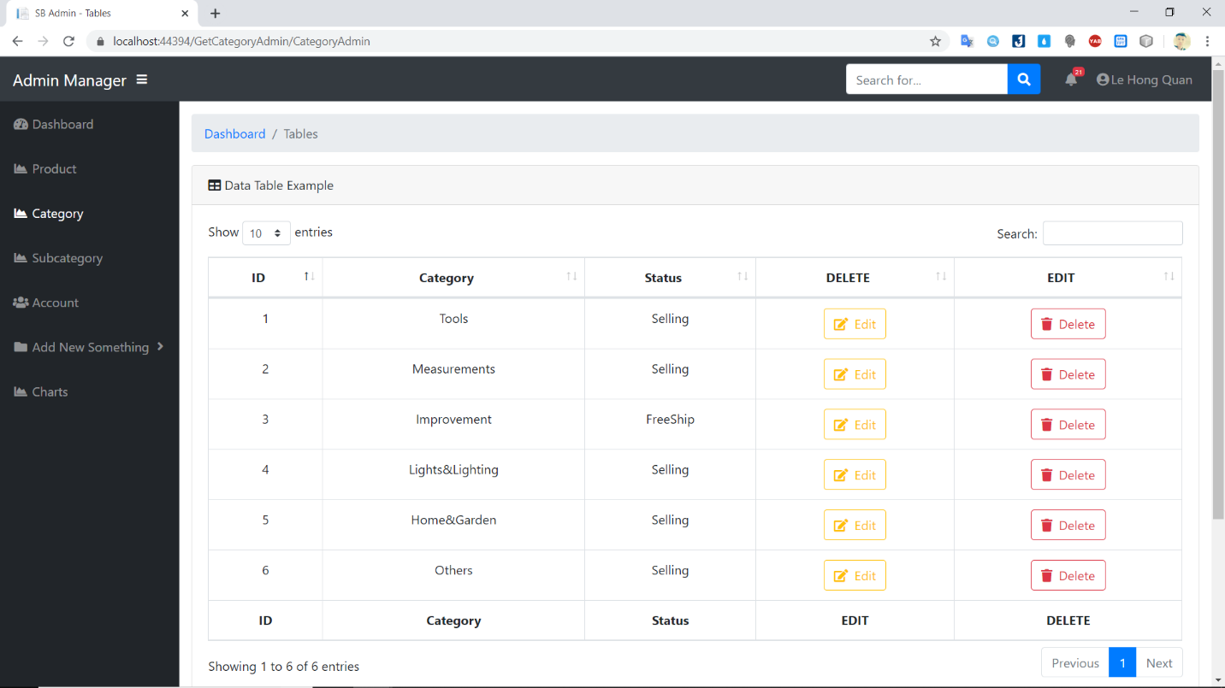

### 5.1.8. Screen “Manage SubCategory”

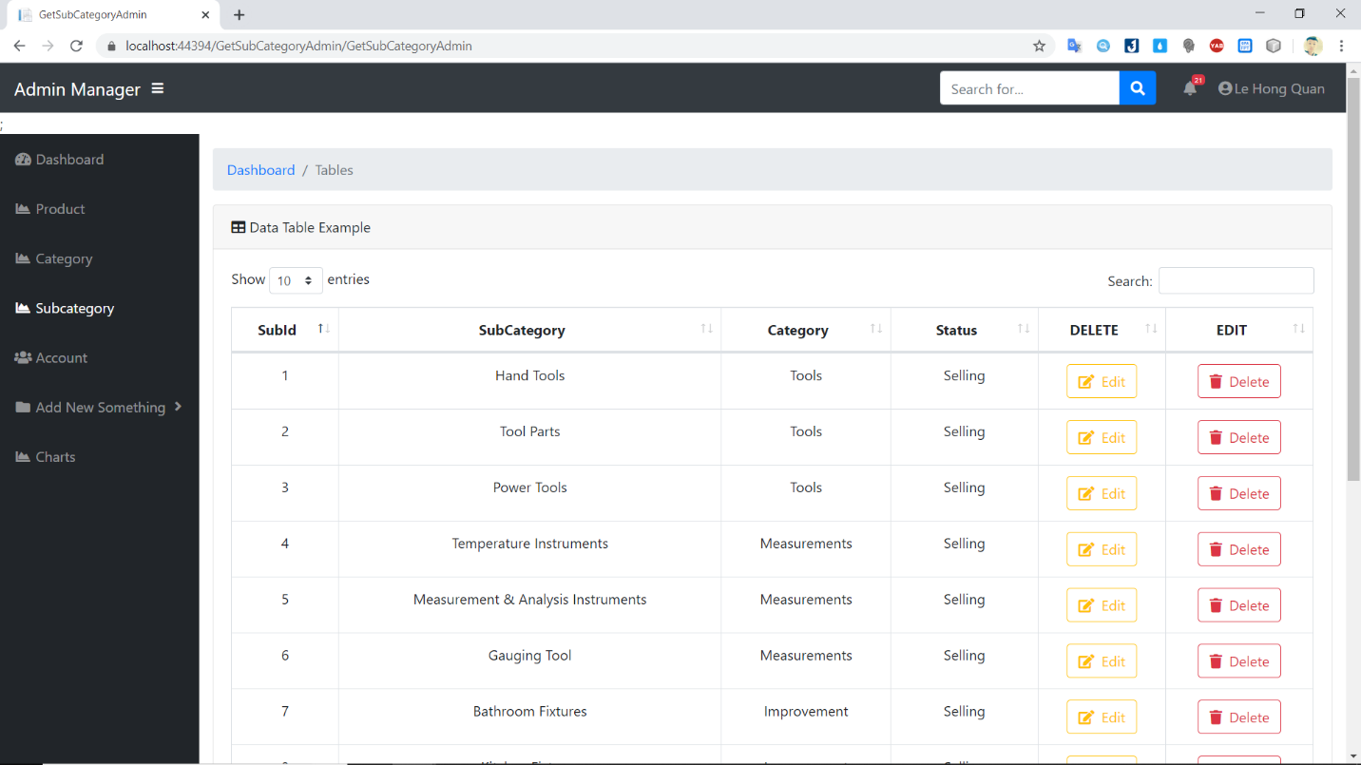

### 5.1.9. Screen “Manage Orders”

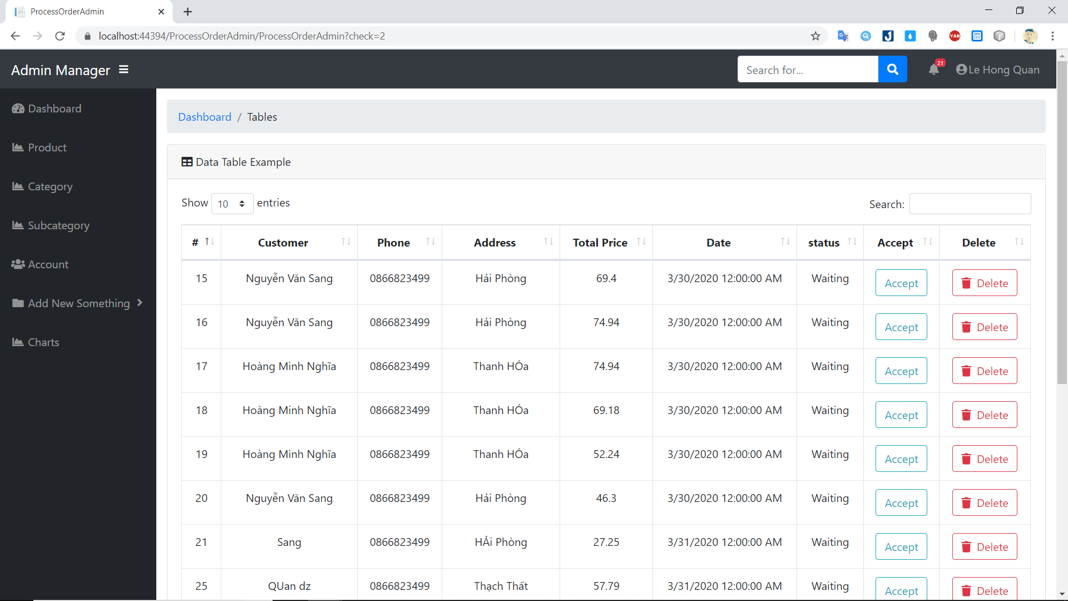

## Interface Flow Diagrams (p. 51)

